Ishmael Madala Molelwane (CSE24-120)
Part A: SYSTEM DOCUMENTATION
1 Requirement Elicitation
1.1 Functional Requirement
They describe what the banking system must do to meet user’s needs. The Banking System must:
- Open Accounts for Customer
The System must allow customers to open accounts online upon provision of personal details(name, surname, address and employment information for ‘Cheque Account’).
- Deposit Funds
Customer must be able to deposit money into any of their accounts.
- Withdraw Funds
Customers must be able to withdraw money from Investment and Cheque accounts only (Savings does not support withdrawals).
- Interest Calculation
The system must automatically calculate and credit monthly interest to eligible accounts.
- Transaction History
Customers must be able to view a detailed transaction history for each account, Including (date of transaction, type of transaction(deposit/withdraw), amount involved and balance after transaction.
- Login
Customer must login securely to access their accounts.
- Eligibility Validation
The system must enforce account specific rules:
- Investment account must start with BWP 500 deposit or more.
- Cheque amount require employment details.

1.2 Non-Functional Requirements
They define how the banking system performs and behave:
- Security
The system must protect customer data through secure login & encrypted storage.
- Performance
System must respond quickly to user action and handle multiple users simultaneously.
- Usability
System must be user-friendly cater for those with less technical skills.
- Automation and Reliability
Monthly Interest calculations and crediting must be fully automated, and system must ensure accurate interest calculation and transaction history records.

2. Structural UML Modelling
2.1 System Use Case Diagram
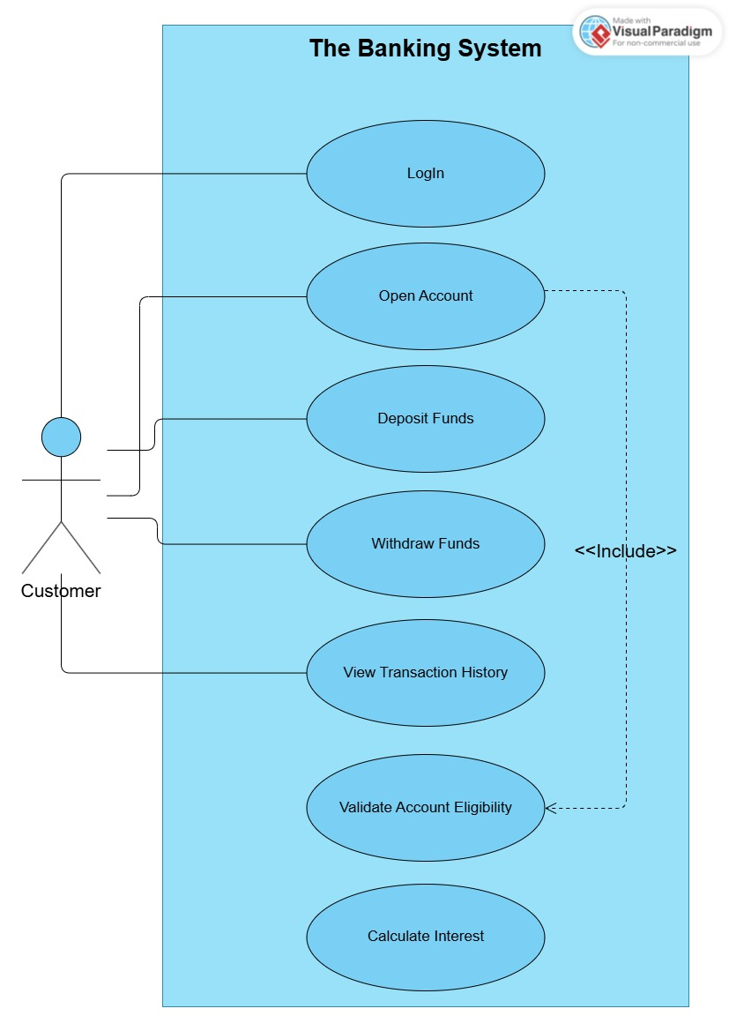
2.2 Class Diagram
I
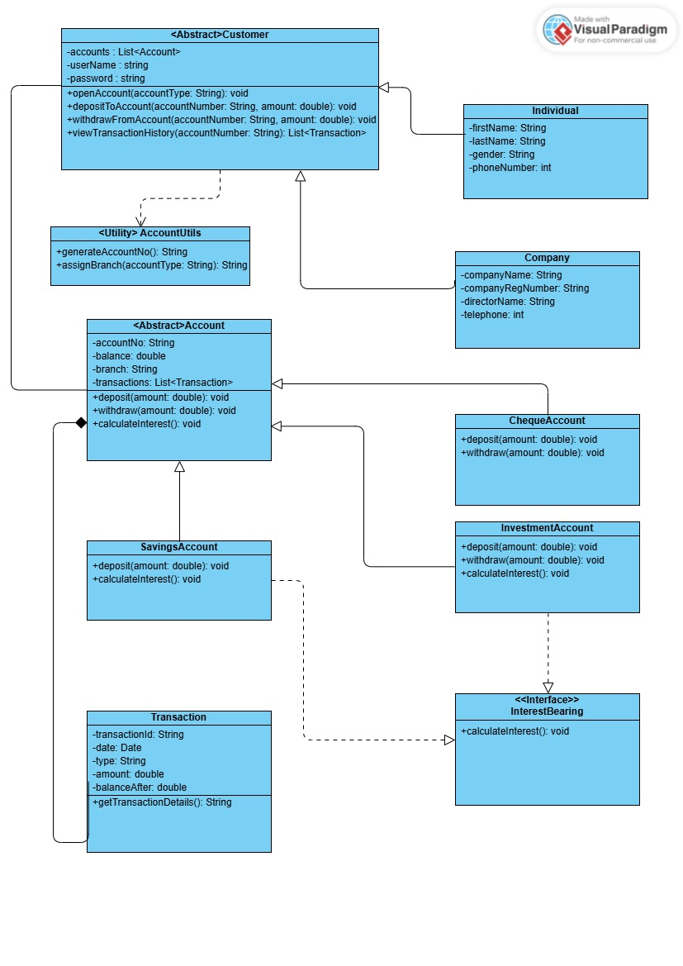
3. Behavioural Modelling
3.1 Sequence Diagram
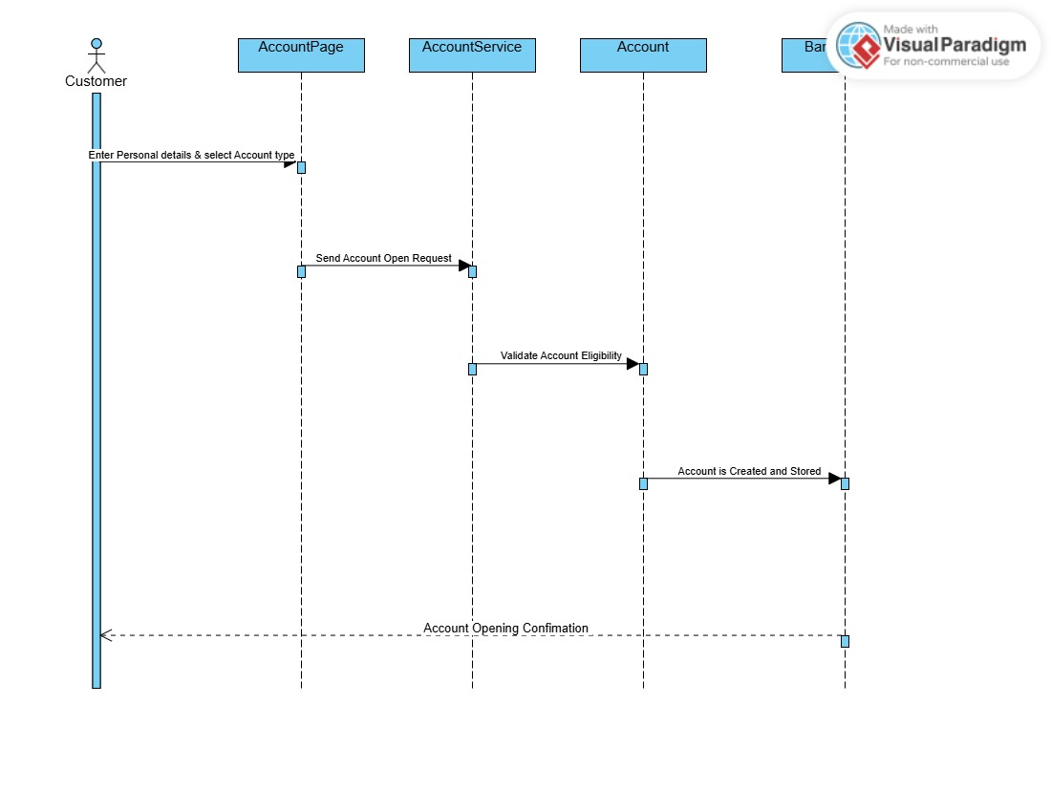
Opening An Account Sequence

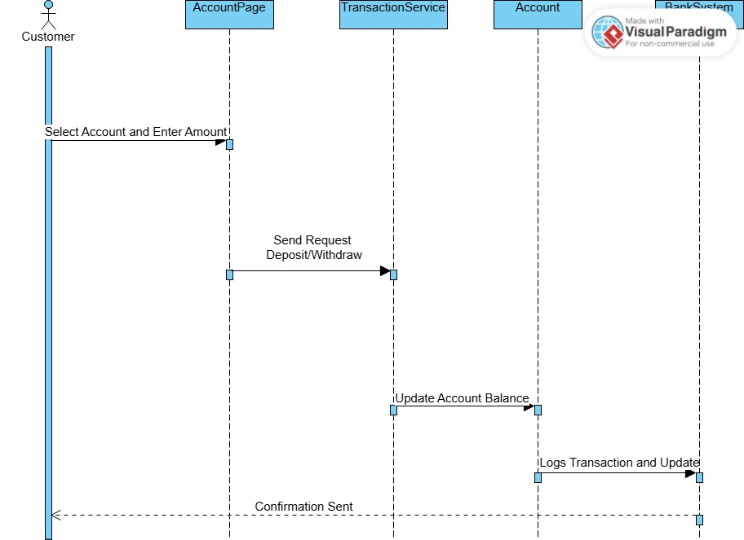
Depositing/withdrawing Funds Sequence

Mock Interview Record
Interviewee: Kentsenao Baseki
Interviewer: Ishmael M Molelwane
Date:18/09/2025
Venue: Online Teams Meeting
Interview Format: Formal Question & Answer
Q1.Who is expected to operate the system? Does it require a bank teller?
Answer: The system is designed for customers only, all operations are customer driven.
Q2. What should system do first?
Answer: The system should allow customers to open an account online by capturing their personal details. No registration.
Q3. What are rules for opening an account?
Answer: Investment need BWP 500 minimum and Cheque requires job/employment info and Savings Account no special requirements but withdrawal is not allowed.
Q4. What should happen if customer tries to open Investment Account with less than BWP 500 deposit?
Answer: The system should reject and notify customer the minimum deposit requirement has not been met.
Q5. Does monthly interest require human approval or is it automated ?
Answer: Fully automated. The system calculates and credit interest.
Q6. Are interest rate the same for individual and companies?
Answer: Yes, interest rates are fixed regardless of whether account holder is individual or a company.

